Computer vision – PRACTICAL CODES

ASHIK C SABU

192124005

Q1.

AIM :

To Perform basic Image Handling and processing operations on the image. Read an image in python and Convert an Image to Grayscale

SOURCE CODE :

import cv2

image_path = "C://Users//ASHIK C SABU//Desktop//supraaa//supra.jpg"

image = cv2.imread(image_path)

gray_image = cv2.cvtColor(image, cv2.COLOR_BGR2GRAY)

cv2.imshow('Original Image', image)

cv2.imshow('Grayscale Image', gray_image)

cv2.waitKey(0)

cv2.destroyAllWindows()

INPUT :

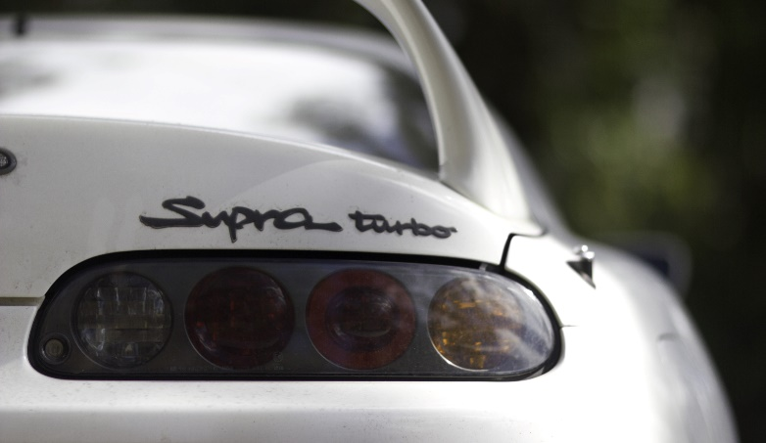

OUTPUT :

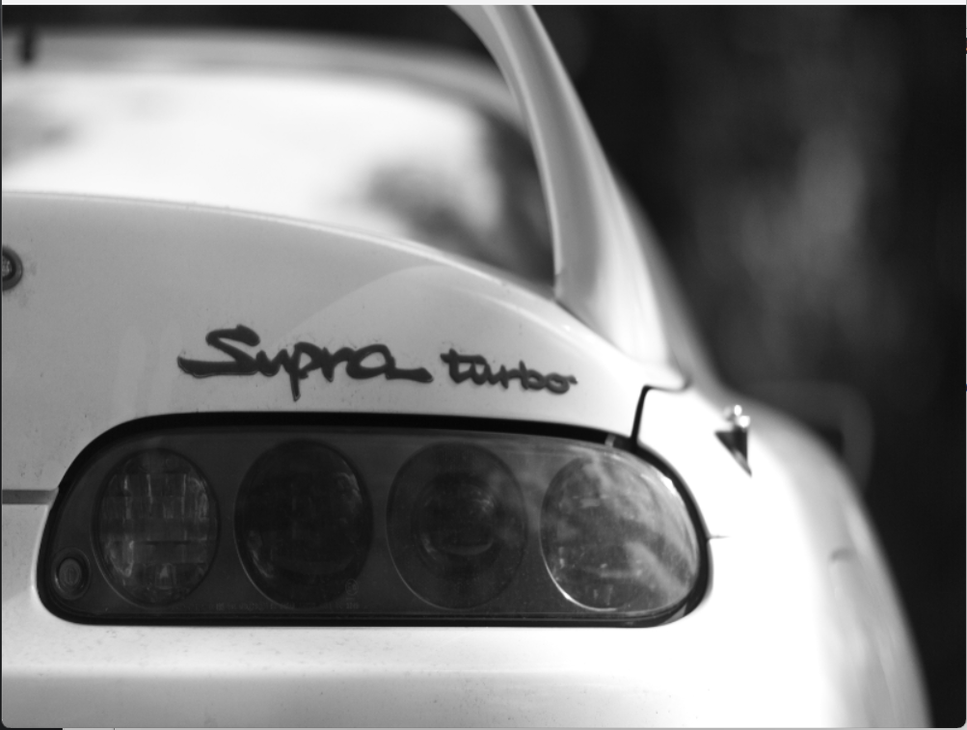

Q2.

AIM :

To perform basic Image Handling and processing operations on the image.Read an image in python and Convert an Image to Blur using GaussianBlur.

SOURCE CODE :

import cv2

image_path = "C://Users//ASHIK C SABU//Desktop//supraaa//supra.jpg"

image = cv2.imread(image_path)

blurred_image = cv2.GaussianBlur(image, (5, 5), 0)

cv2.imshow('Original Image', image)

cv2.imshow('Blurred Image', blurred_image)

cv2.waitKey(0)

cv2.destroyAllWindows()

INPUT:

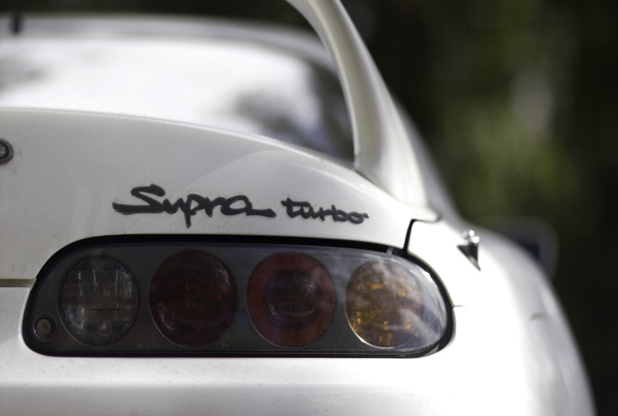

OUTPUT:



Q3.

AIM :

To perform Basic Operations to Convert image to show outline Canny function.

SOURCE CODE :

import cv2

import numpy as np

kernel = np.ones((5,5),np.uint8)

print(kernel)

path = "C://Users//ASHIK C SABU//Desktop//supraaa//supra.jpg"

img =cv2.imread(path)

imgGray = cv2.cvtColor(img,cv2.COLOR_BGR2GRAY)

imgBlur = cv2.GaussianBlur(imgGray,(7,7),0)

imgCanny = cv2.Canny(imgBlur,100,200)

desired_width = 800

desired_height = 600

img_resized = cv2.resize(imgCanny, (desired_width, desired_height))

cv2.imshow("Img Canny",img_resized)

cv2.waitKey(0)

INPUT:

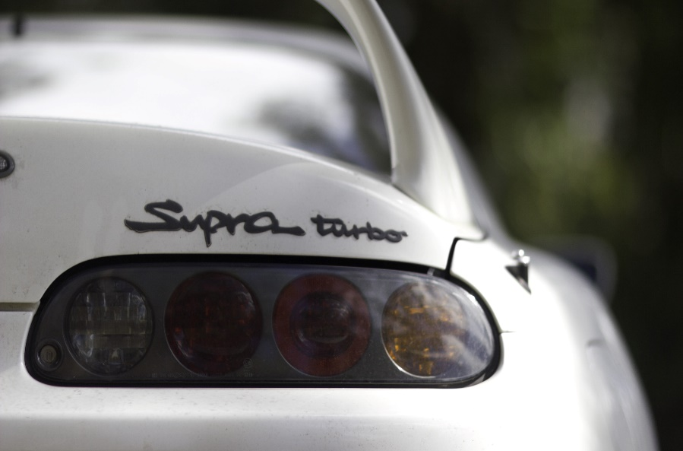

OUTPUT:

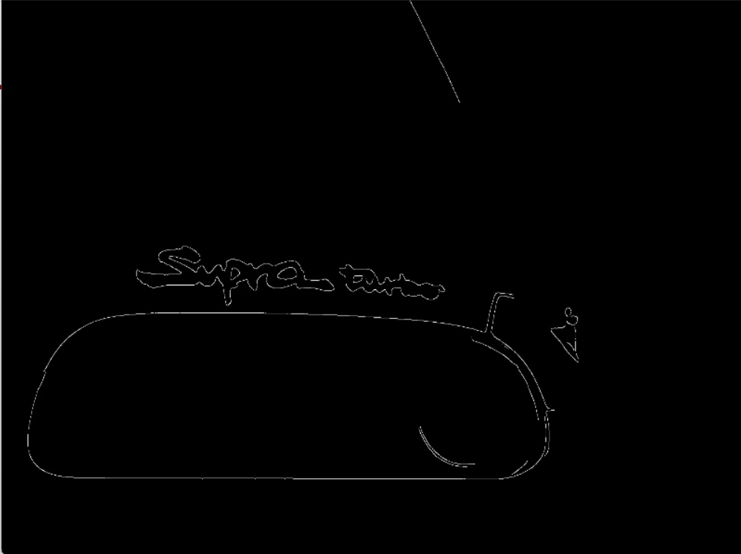

Q4.

AIM :

To perform basic Image Handling and processing operations on the image Read an image in python and Dilate an Image using Dilate function

SOURCE CODE :

import cv2

import numpy as np

kernel = np.ones((5,5),np.uint8)

print(kernel)

path = "C://Users//ASHIK C SABU//Desktop//supraaa//supra.jpg"

img =cv2.imread(path)

imgGray = cv2.cvtColor(img,cv2.COLOR_BGR2GRAY)

imgBlur = cv2.GaussianBlur(imgGray,(7,7),0)

imgCanny = cv2.Canny(imgBlur,100,200)

imgDilation = cv2.dilate(imgCanny,kernel , iterations = 10)

imgEroded = cv2.erode(imgDilation,kernel,iterations=2)

desired_width = 800

desired_height = 600

img_resized = cv2.resize(imgEroded, (desired_width, desired_height))

cv2.imshow("Img Erosion",img_resized)

cv2.waitKey(0)

INPUT:



OUTPUT:

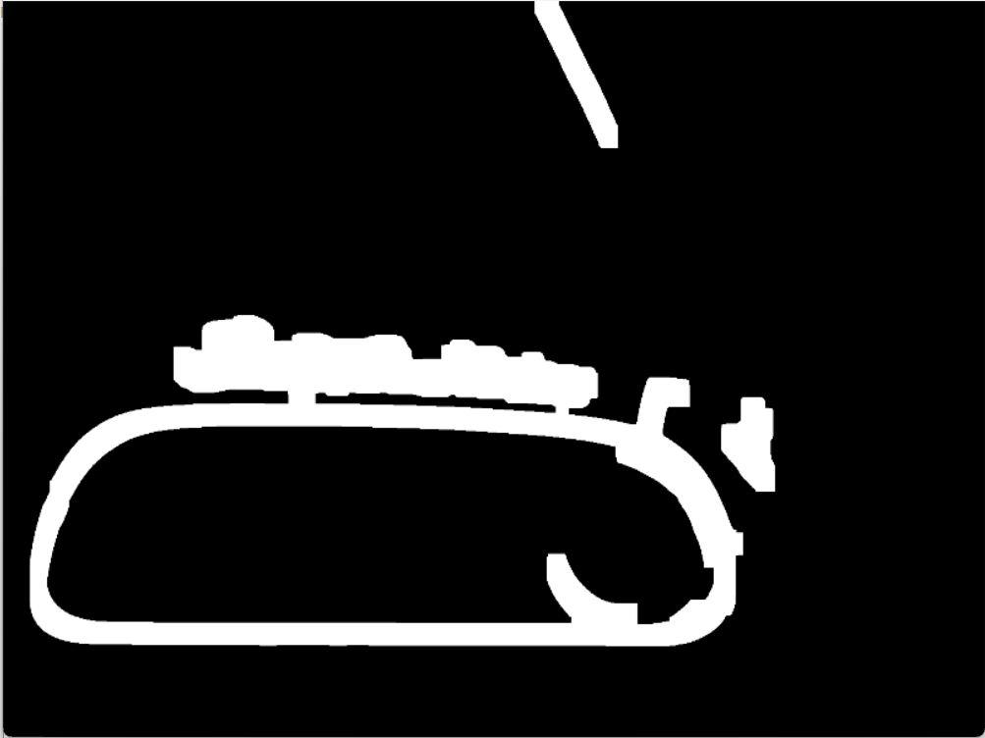

Q5.

AIM :

To Perform basic Image Handling and processing operations on the image Read an image in python and Erode an Image using erode function

SOURCE CODE :

import cv2

import numpy as np

kernel = np.ones((5,5),np.uint8)

print(kernel)

path = "C://Users//ASHIK C SABU//Desktop//supraaa//supra.jpg"

img =cv2.imread(path)

imgGray = cv2.cvtColor(img,cv2.COLOR_BGR2GRAY)

imgBlur = cv2.GaussianBlur(imgGray,(7,7),0)

imgCanny = cv2.Canny(imgBlur,100,200)

imgDilation = cv2.dilate(imgCanny,kernel , iterations = 10)

imgEroded = cv2.erode(imgDilation,kernel,iterations=2)

desired_width = 800

desired_height = 600

img_resized = cv2.resize(imgEroded, (desired_width, desired_height))

cv2.imshow("Img Erosion",img_resized)

cv2.waitKey(0)

INPUT:



OUTPUT:

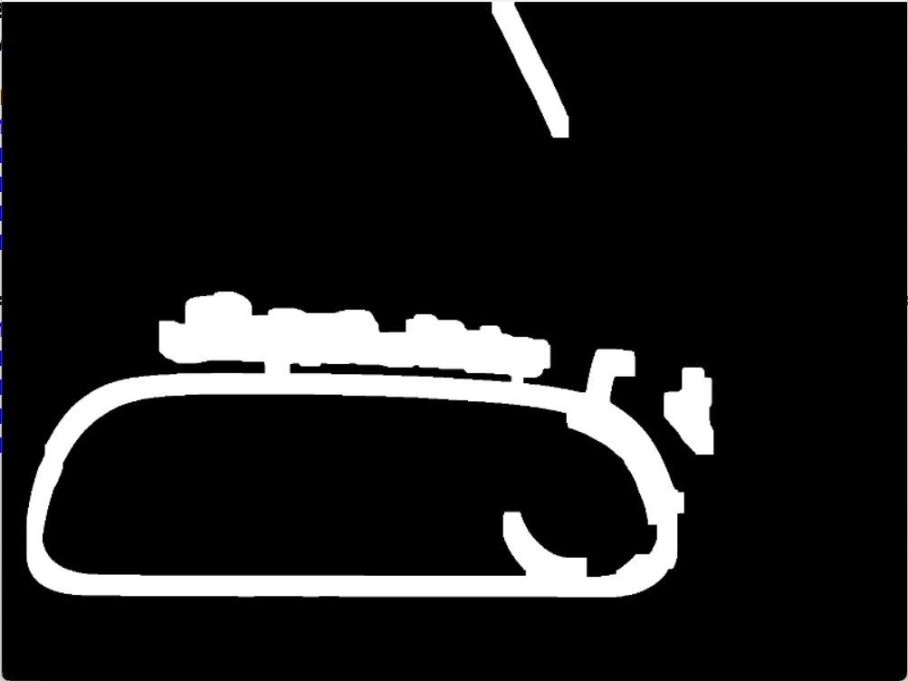

Q6.

AIM :

Perform basic video processing operations on the captured video• Read captured video in python and display the video, in slow motion and in fast motion.

SOURCE CODE :

import cv2

import numpy as np

cap = cv2.VideoCapture("C://Users//ASHIK C SABU//Desktop//supraaa//car.mp4")

if (cap.isOpened()== False):

print("Error opening video file")

while(cap.isOpened()):

ret, frame = cap.read()

if ret == True:

cv2.imshow('Frame', frame)

if cv2.waitKey(250) & 0xFF == ord('q'):

break

else:

break

cap.release()

cv2.destroyAllWindows()

OUTPUT:

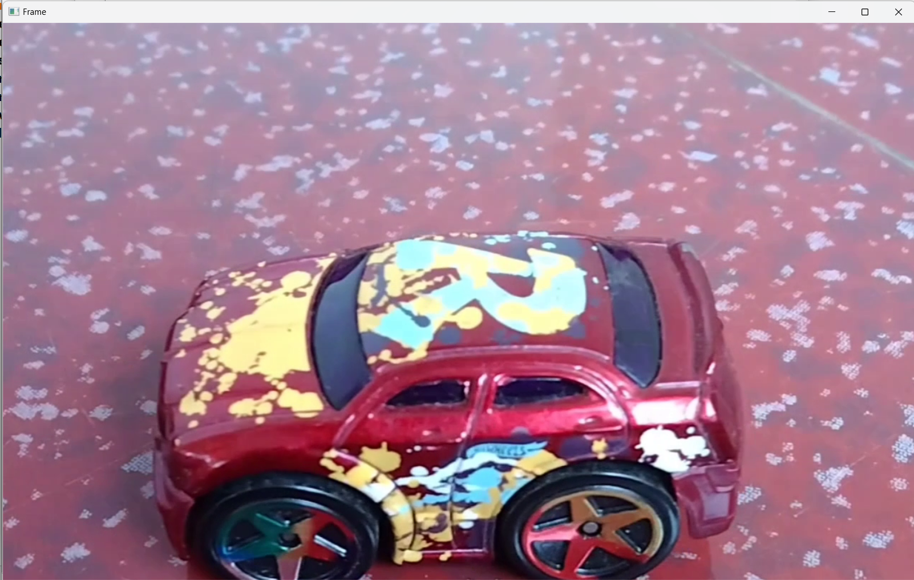

Q7.

AIM :

Capture video from web Camera and Display the video, in slow motion and in fast motion operations on the captured video.

SOURCE CODE :

import cv2

cap = cv2.VideoCapture(0)

height = int(cap.get(cv2.CAP_PROP_FRAME_HEIGHT))

width = int(cap.get(cv2.CAP_PROP_FRAME_WIDTH))

fps = cap.get(cv2.CAP_PROP_FPS)

path = "0"

fourcc = cv2.VideoWriter_fourcc(*'mp4v')

output = cv2.VideoWriter(path, fourcc, 2,(width, height))

while True:

ret, frame = cap.read()

cv2.imshow("frame", frame)

output.write(frame)

k = cv2.waitKey(24)

if k == ord("q"):

break

cap.release()

output.release()

cv2.destroyAllWindows()

OUTPUT:

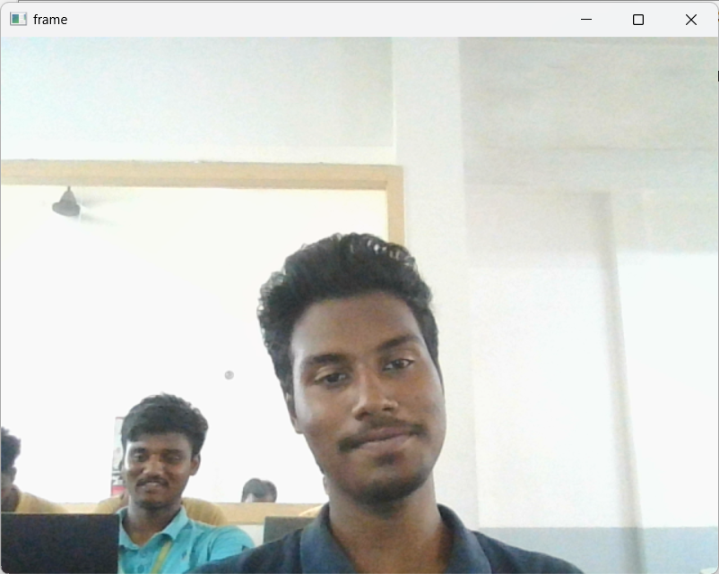

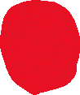

Q8.

AIM :

To perform Scaling an image to its Bigger and Smaller sizes

SOURCE CODE :

import cv2

import numpy as np

kernel = np.ones((5,5),np.uint8)

img = cv2.imread("C://Users//ASHIK C SABU//Desktop//supraaa//supra.jpg",cv2.IMREAD_COLOR)

img = cv2.resize(img,(600,600))

cv2.imshow("image",img)

cv2.waitKey(0)

OUTPUT:

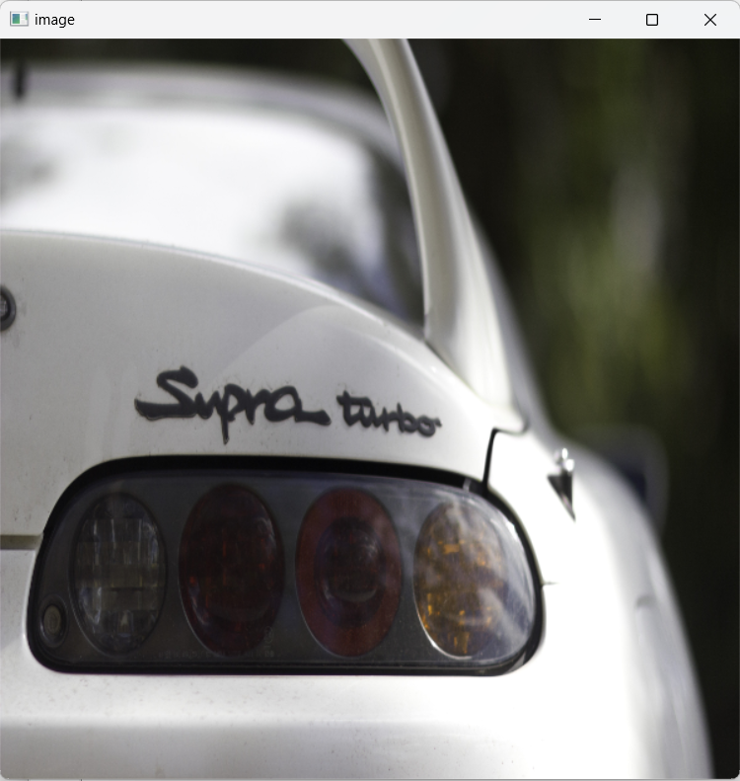

Q9.

AIM :

Perform Rotation of an image to clockwise and counter clockwise direction.

SOURCE CODE :

import cv2

path ="C://Users//ASHIK C SABU//Desktop//supraaa//supra.jpg"

src = cv2.imread(path)

window_name = 'Image'

image = cv2.rotate(src, cv2.ROTATE_180)

img = cv2.resize(image,(600,600))

cv2.imshow(window_name, img)

cv2.waitKey(0)

OUTPUT:

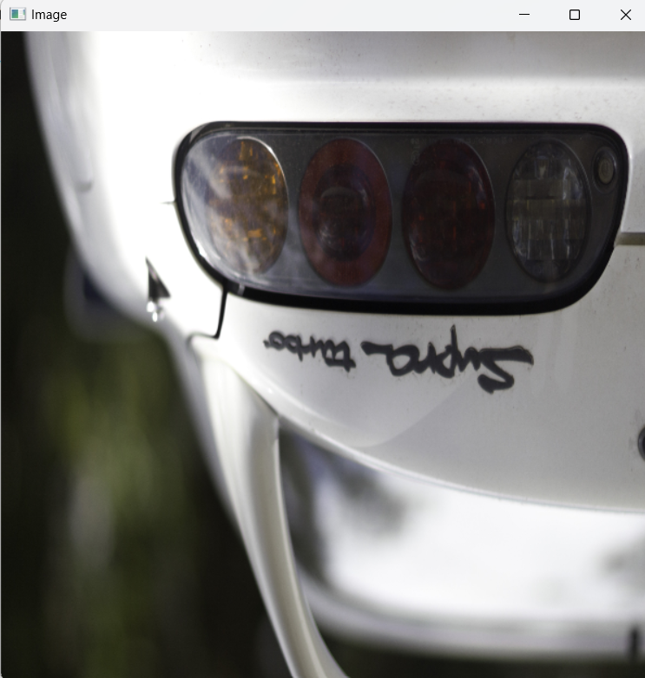

Q10.

AIM :

The Aim of the Experiment is to perform Rotation of an image along 90 degree.

SOURCE CODE :

import cv2

image = cv2.imread("D:\Compute vision\pexels-photo-2138922.jpeg")

height, width = image.shape[:2]

rotated_image = cv2.rotate(image, cv2.ROTATE_90_CLOCKWISE)

cv2.imshow('Rotated Image', rotated_image)

cv2.waitKey(0)

cv2.destroyAllWindows()

OUTPUT:

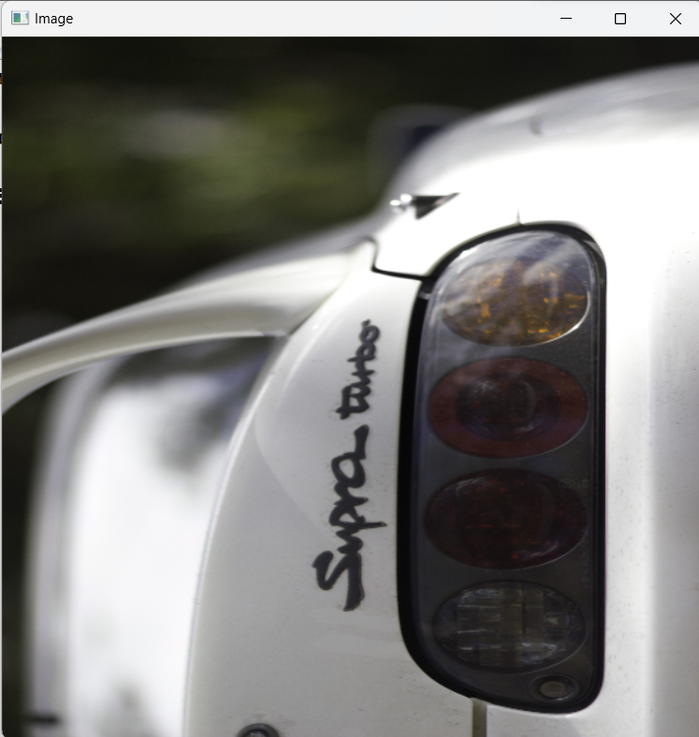

Q11.

AIM :

Perform Affine Transformation on the image.

SOURCE CODE :

import cv2

import numpy as np

image_path = "C://Users//ASHIK C SABU//Desktop//supraaa//supra.jpg"

image = cv2.imread(image_path)

rows, cols, _ = image.shape

transformation_matrix = np.float32([[1, 0, 50], [0, 1, 30]])

affine_image = cv2.warpAffine(image, transformation_matrix, (cols, rows))

img = cv2.resize(image,(600,600))

img2 = cv2.resize(affine_image,(600,600))

cv2.imshow('Original Image', img)

cv2.imshow('Affine Transformed Image', img2)

cv2.waitKey(0)

cv2.destroyAllWindows()

OUTPUT:

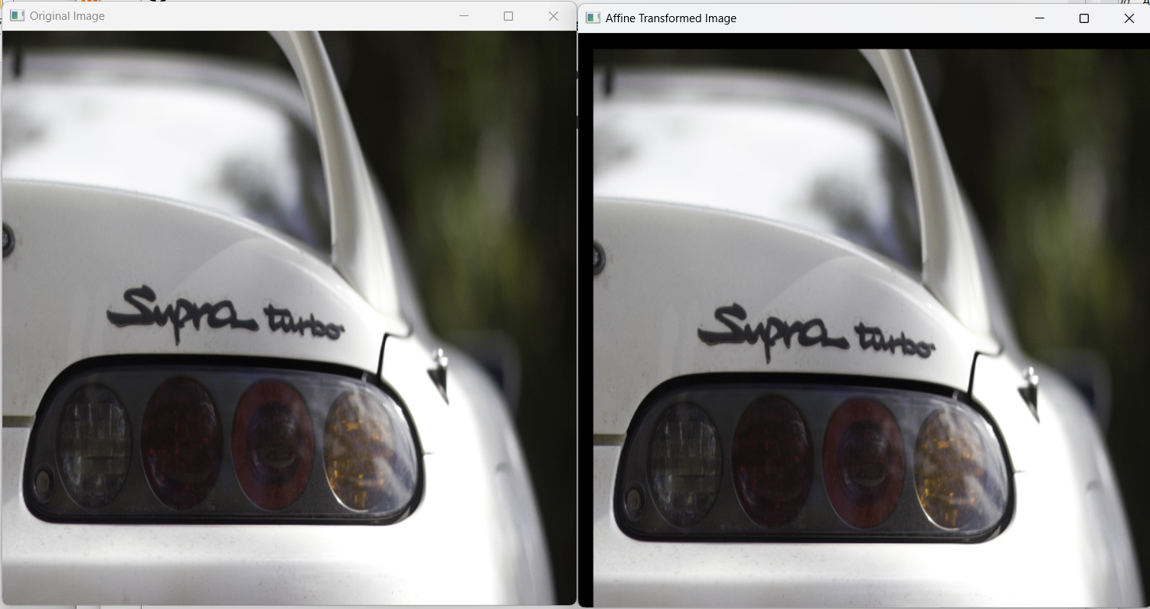

Q12.

AIM :

Perform Perspective Transformation on the image.

SOURCE CODE :

import cv2

import numpy as np

img = cv2.imread("C://Users//ASHIK C SABU//Desktop//supraaa//supra.jpg")

rows,cols,ch = img.shape

pts1 = np.float32([[56,65],[368,52],[28,387],[389,390]])

pts2 = np.float32([[100,50],[300,0],[0,300],[300,300]])

M = cv2.getPerspectiveTransform(pts1,pts2)

dst = cv2.warpPerspective(img,M,(cols, rows))

cv2.imshow('Transformed Image', dst)

cv2.waitKey(0)

cv2.destroyAllWindows()

OUTPUT:

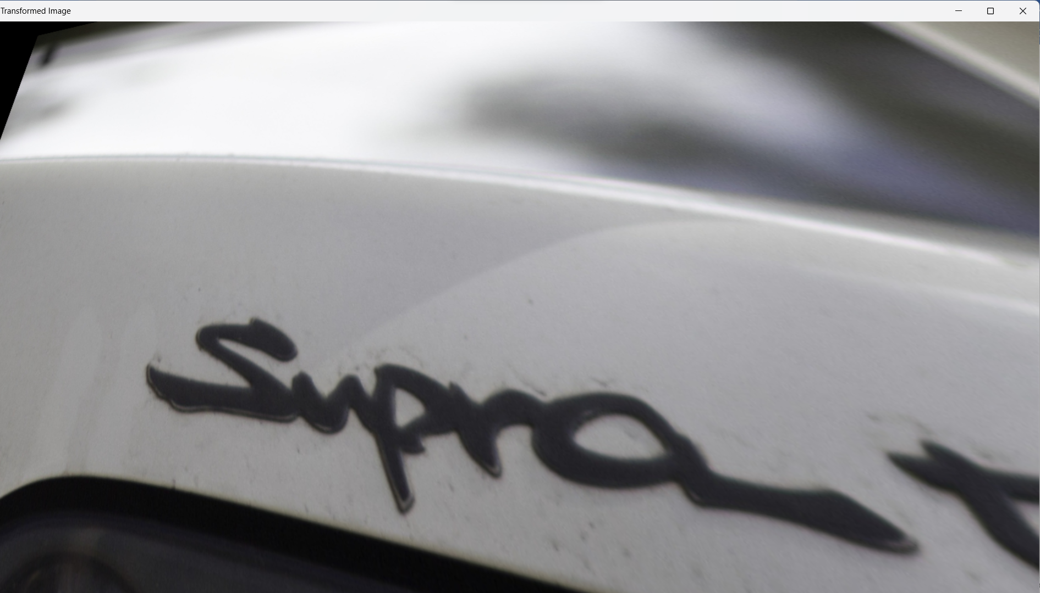

Q13.

AIM :

Perform Perspective Transformation on the Video.

SOURCE CODE :

import cv2

import numpy as np

img = cv2.imread("C://Users//ASHIK C SABU//Desktop//supraaa//supra.jpg")

rows,cols,ch = img.shape

pts1 = np.float32([[56,65],[368,52],[28,387],[389,390]])

pts2 = np.float32([[100,50],[300,0],[0,300],[300,300]])

M = cv2.getPerspectiveTransform(pts1,pts2)

dst = cv2.warpPerspective(img,M,(cols, rows))

cv2.imshow('Transformed Image', dst)

cv2.waitKey(0)

cv2.destroyAllWindows()

OUTPUT:

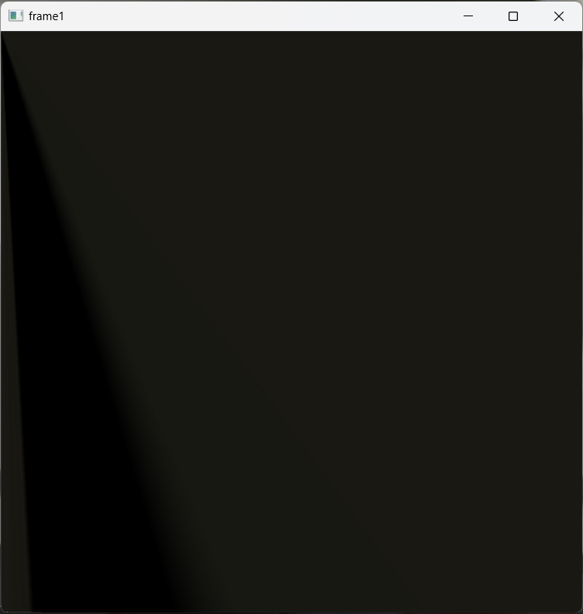

Q14.

AIM :

Perform transformation using Homography matrix.

SOURCE CODE :

import cv2

import numpy as np

im_src = cv2.imread("C://Users//ASHIK C SABU//Desktop//supraaa//supra.jpg")

pts_src = np.array([[141, 131], [480, 159], [493, 630],[64, 601]])

im_dst = cv2.imread("C://Users//ASHIK C SABU//Desktop//supraaa//supra.jpg")

pts_dst = np.array([[318, 256],[534, 372],[316, 670],[73, 473]])

h, status = cv2.findHomography(pts_src, pts_dst)

im_out = cv2.warpPerspective(im_src, h, (im_dst.shape[1],im_dst.shape[0]))

img = cv2.resize(im_src,(600,600))

img1 = cv2.resize(im_dst,(600,600))

img2 = cv2.resize(im_out,(600,600))

cv2.imshow("Source Image", img)

cv2.imshow("Destination Image", img1)

cv2.imshow("Warped Source Image", img2)

cv2.waitKey(0)

OUTPUT:

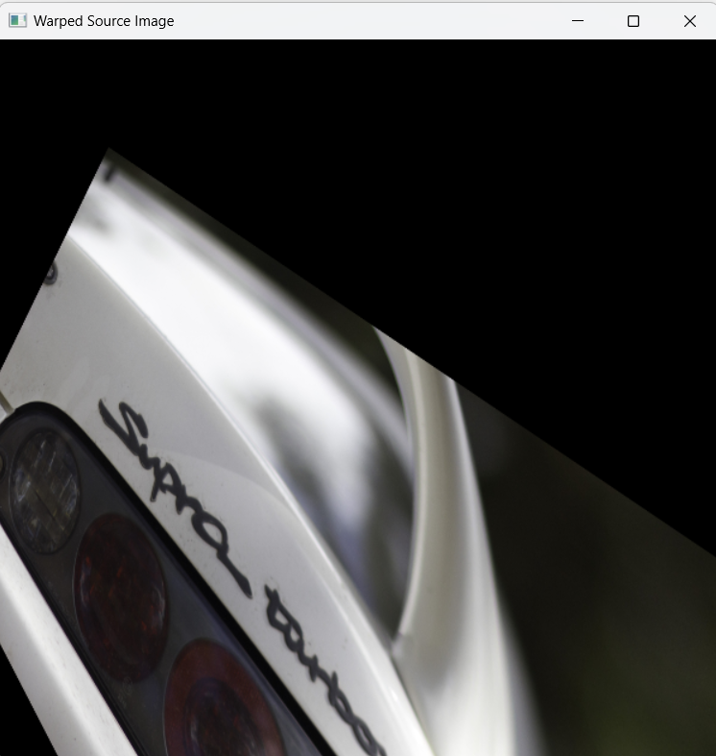

Q15.

AIM :

Perform transformation using Direct Linear Transformation.

SOURCE CODE :

import cv2

import numpy as np

img1 = cv2.imread("C://Users//ASHIK C SABU//Desktop//supraaa//supra.jpg")

img2 = cv2.imread("C://Users//ASHIK C SABU//Desktop//supraaa//supra1.jpg")

pts1 = np.array([[50, 50], [200, 50], [50, 200], [200, 200]])

pts2 = np.array([[100, 100], [300, 100], [100, 300], [300, 300]])

H, _ = cv2.findHomography(pts1, pts2)

dst = cv2.warpPerspective(img1, H, (img2.shape[1], img2.shape[0]))

img = cv2.resize(img1,(600,600))

img3 = cv2.resize(img2,(600,600))

img4 = cv2.resize(dst,(600,600))

cv2.imshow('img1', img)

cv2.imshow('img2', img3)

cv2.imshow('dst', img4)

cv2.waitKey(0)

cv2.destroyAllWindows()

OUTPUT:

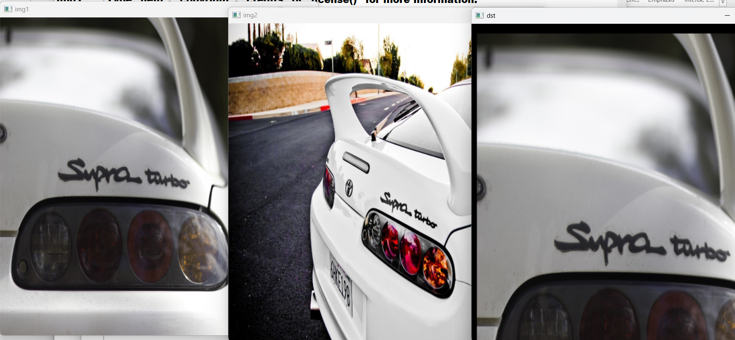

Q16.

AIM :

Perform Edge detection using canny method

SOURCE CODE :

import cv2

img = cv2.imread("C://Users//ASHIK C SABU//Desktop//supraaa//supra.jpg")

cv2.imshow('Original', img)

cv2.waitKey(0)

img_gray = cv2.cvtColor(img, cv2.COLOR_BGR2GRAY)

img_blur = cv2.GaussianBlur(img_gray, (3,3), 0)

edges = cv2.Canny(image=img_blur, threshold1=100, threshold2=200)

cv2.imshow('Canny Edge Detection', edges)

cv2.waitKey(0)

cv2.destroyAllWindows()

OUTPUT:

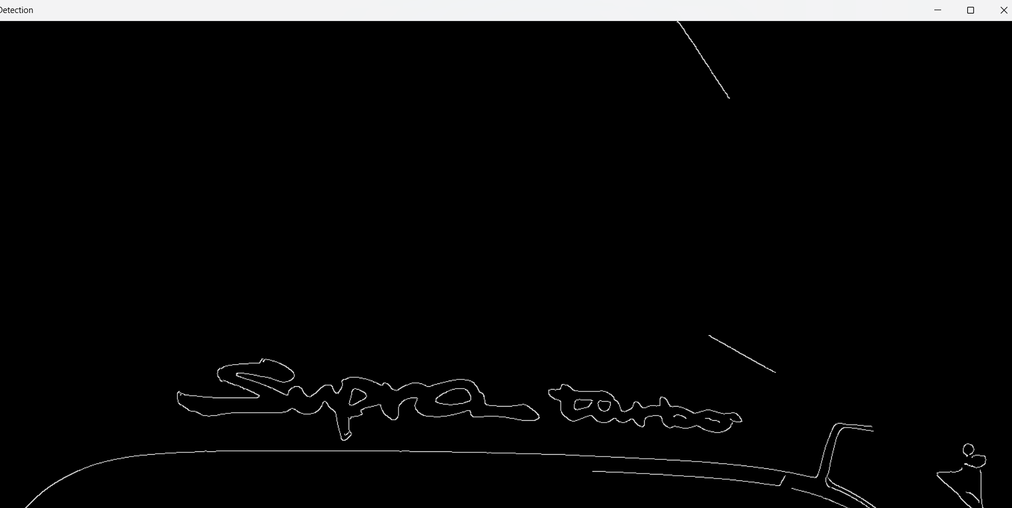

Q17.

AIM :

Perform Edge detection using Sobel Matrix along X axis

SOURCE CODE :

import cv2

img = cv2.imread("C://Users//ASHIK C SABU//Desktop//supraaa//supra.jpg")

cv2.imshow('Original', img)

cv2.waitKey(0)

img_gray = cv2.cvtColor(img, cv2.COLOR_BGR2GRAY)

img_blur = cv2.GaussianBlur(img_gray, (3,3), 0)

sobelx = cv2.Sobel(src=img_blur, ddepth=cv2.CV_64F, dx=1, dy=0, ksize=5)

cv2.imshow('Sobel X', sobelx)

cv2.waitKey(0)

OUTPUT:

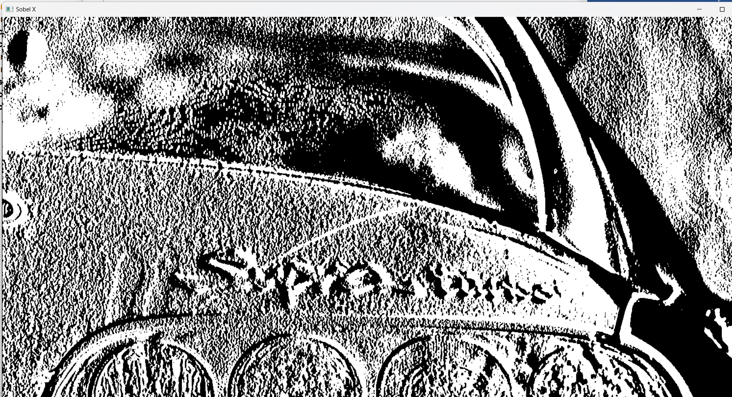

Q18.

AIM :

Perform Edge detection using Sobel Matrix along Y axis

SOURCE CODE :

import cv2

img = cv2.imread("C://Users//ASHIK C SABU//Desktop//supraaa//supra.jpg")

cv2.imshow('Original', img)

cv2.waitKey(0)

img_gray = cv2.cvtColor(img, cv2.COLOR_BGR2GRAY)

img_blur = cv2.GaussianBlur(img_gray, (3,3), 0)

sobely = cv2.Sobel(src=img_blur, ddepth=cv2.CV_64F, dx=0, dy=1, ksize=5)

cv2.imshow('Sobel Y', sobely)

cv2.waitKey(0)

OUTPUT:

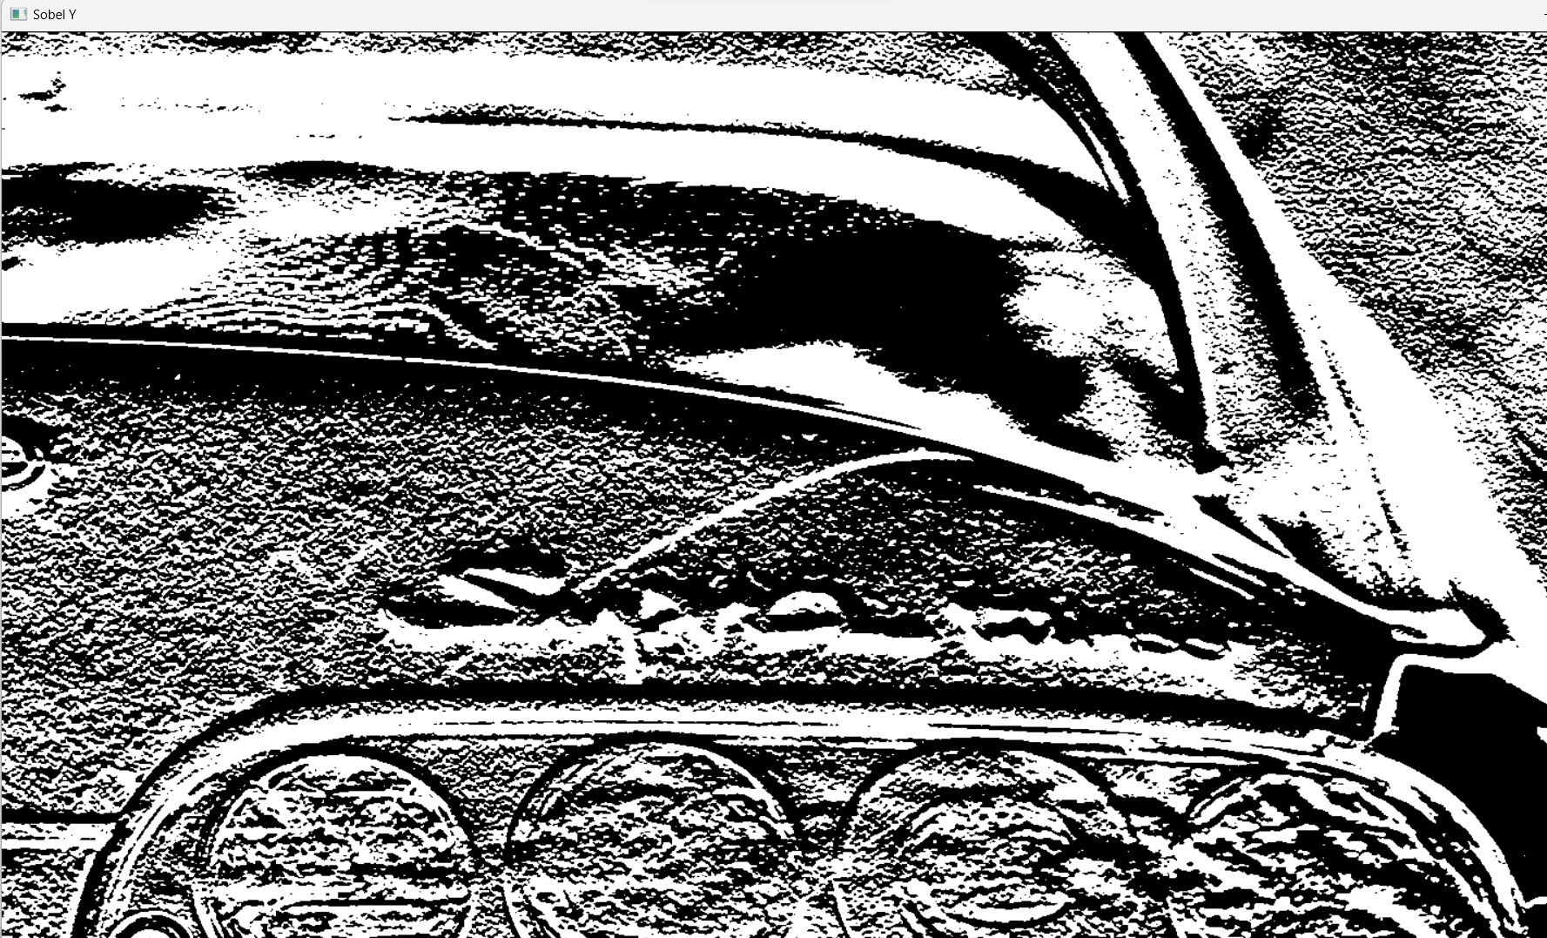

Q19.

AIM :

Perform Edge detection using Sobel Matrix along XY axis

SOURCE CODE :

import cv2

img = cv2.imread("C://Users//ASHIK C SABU//Desktop//supraaa//supra.jpg")

cv2.imshow('Original', img)

cv2.waitKey(0)

img_gray = cv2.cvtColor(img, cv2.COLOR_BGR2GRAY)

img_blur = cv2.GaussianBlur(img_gray, (3,3), 0)

sobelxy = cv2.Sobel(src=img_blur, ddepth=cv2.CV_64F, dx=1, dy=1, ksize=5)

cv2.imshow('Sobel X Y using Sobel() function', sobelxy)

cv2.waitKey(0)

OUTPUT:

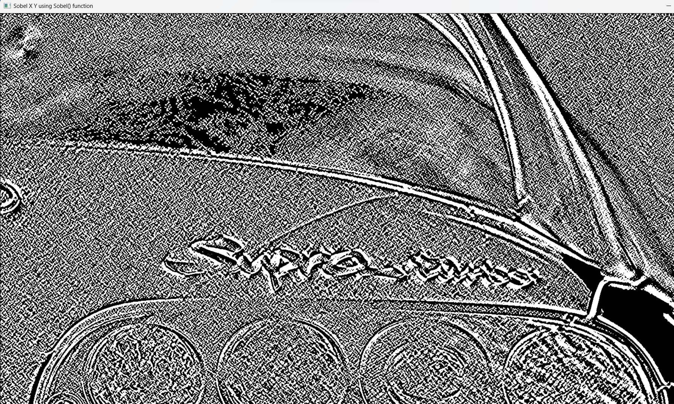

Q20.

AIM :

Perform Sharpening of Image using Laplacian mask with negative center coefficient.

SOURCE CODE :

import cv2

import numpy as np

img = cv2.imread("C://Users//ASHIK C SABU//Desktop//supraaa//supra.jpg")

gray = cv2.cvtColor(img, cv2.COLOR_BGR2GRAY)

kernel = np.array([[0,1,0], [1,-8,1], [0,1,0]])

sharpened = cv2.filter2D(gray, -1, kernel)

cv2.imshow('Original', gray)

cv2.imshow('Sharpened', sharpened)

cv2.waitKey(0)

cv2.destroyAllWindows()

OUTPUT:

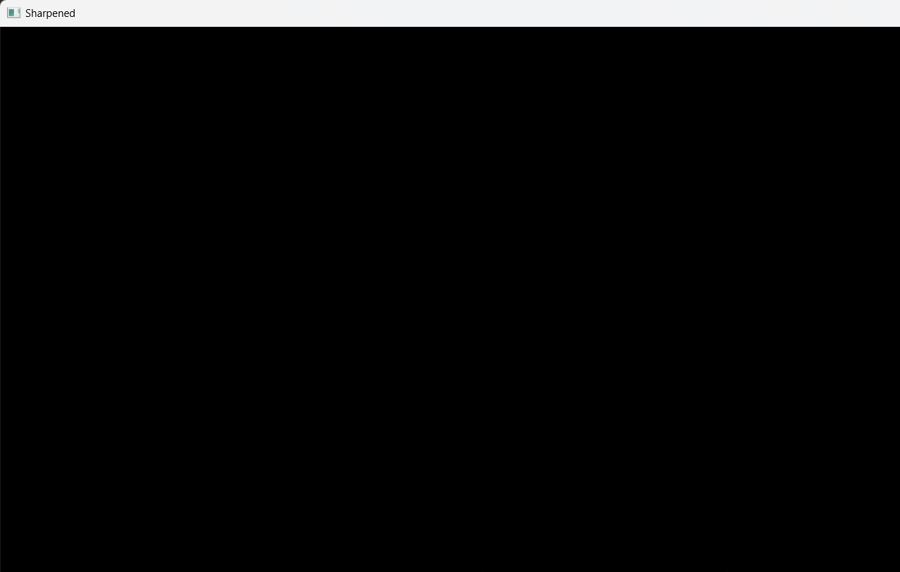

Q21.

AIM :

Perform Sharpening of Image using Laplacian mask implemented with an extension of

diagonal neighbors

SOURCE CODE :

import cv2

import numpy as np

img = cv2.imread("C://Users//ASHIK C SABU//Desktop//supraaa//supra.jpg")

gray = cv2.cvtColor(img, cv2.COLOR_BGR2GRAY)

kernel = np.array([[0,1,0], [1,-4,1], [0,1,0]])

sharpened = cv2.filter2D(gray, -1, kernel)

cv2.imshow('Original', gray)

cv2.imshow('Sharpened', sharpened)

cv2.waitKey(0)

cv2.destroyAllWindows()

OUTPUT:

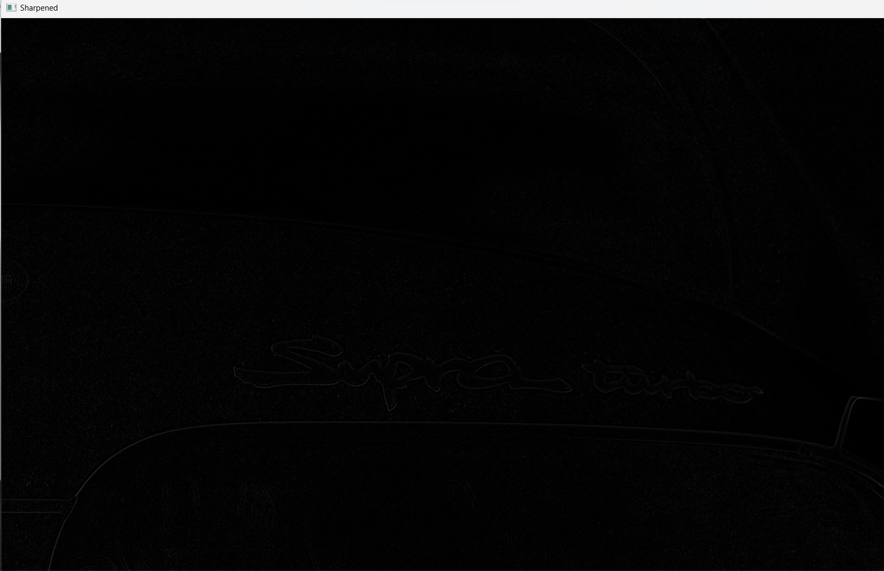

Q22.

AIM :

Perform Sharpening of Image using Laplacian mask with positive center coefficient.

SOURCE CODE :

import cv2

import numpy as np

img = cv2.imread("C://Users//ASHIK C SABU//Desktop//supraaa//supra.jpg")

img = cv2.resize(img,(255, 255))

gray_img = cv2.cvtColor(img, cv2.COLOR_BGR2GRAY)

laplacian_kernel = np.array([[0, -1, 0], [-1, 5, -1], [0, -1, 0]])

sharpened_img = cv2.filter2D(gray_img, -1, laplacian_kernel)

sharpened_img = cv2.cvtColor(sharpened_img, cv2.COLOR_GRAY2BGR)

cv2.imshow('Original Image', img)

cv2.imshow('Sharpened Image', sharpened_img)

cv2.waitKey(0)

cv2.destroyAllWindows()

OUTPUT:

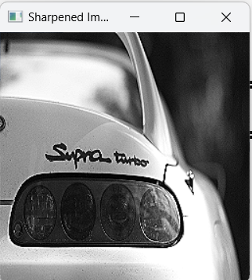

Q23.

AIM :

Perform Sharpening of Image using unsharp masking.

SOURCE CODE :

import cv2

import numpy as np

img = cv2.imread("C://Users//ASHIK C SABU//Desktop//supraaa//supra.jpg")

gray = cv2.cvtColor(img, cv2.COLOR_BGR2GRAY)

laplacian_kernel = np.array([[0, 1, 0],[1, -4, 1],[0, 1, 0]])

laplacian = cv2.filter2D(gray, -1, laplacian_kernel)

sharpened = cv2.add(gray, laplacian)

cv2.imshow('Original Image', gray)

cv2.imshow('Sharpened Image', sharpened)

cv2.waitKey(0)

cv2.destroyAllWindows()

OUTPUT:

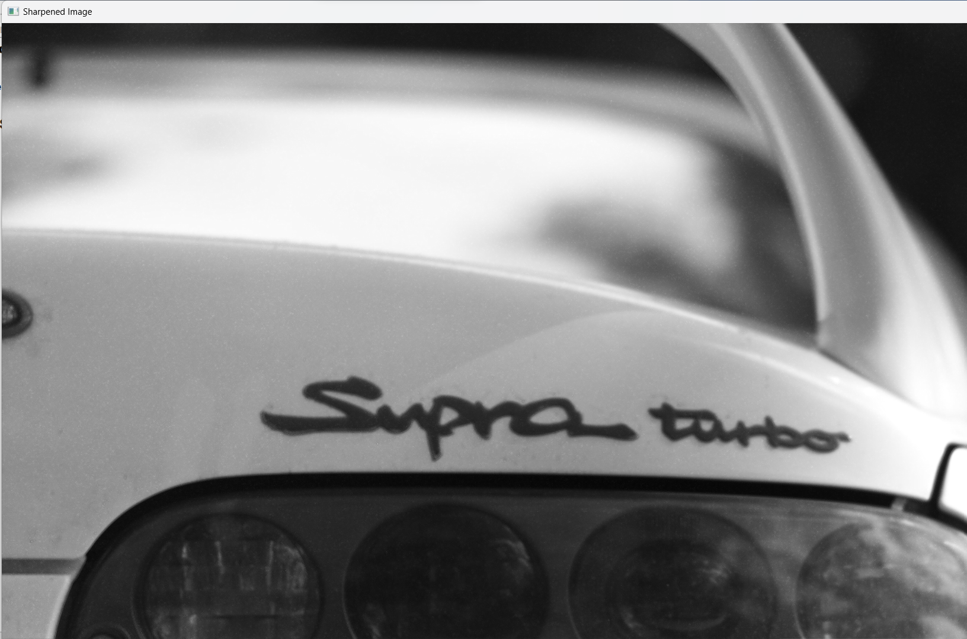

Q24.

AIM :

Perform Sharpening of Image using High-Boost Masks.

SOURCE CODE :

import cv2

import numpy as np

import matplotlib.pyplot as plt

def high_boost_sharpening(image_path, k=1.5):

original_image = cv2.imread(image_path, cv2.IMREAD_GRAYSCALE)

blurred_image = cv2.GaussianBlur(original_image, (5, 5), 0)

high_pass = original_image - blurred_image

sharpened_image = original_image + k * high_pass

return original_image, sharpened_image

image_path = "C://Users//ASHIK C SABU//Desktop//supraaa//supra.jpg"

original_image, sharpened_image = high_boost_sharpening(image_path, k=1.5)

plt.figure(figsize=(10, 5))

plt.subplot(1, 3, 1)

plt.imshow(original_image, cmap='gray')

plt.title('Original Image')

plt.subplot(1, 3, 2)

plt.imshow(sharpened_image, cmap='gray')

plt.title('Sharpened Image')

plt.subplot(1, 3, 3)

plt.imshow(original_image - sharpened_image, cmap='gray')

plt.title('Detail (High-Pass)')

plt.tight_layout()

plt.show()

OUTPUT:

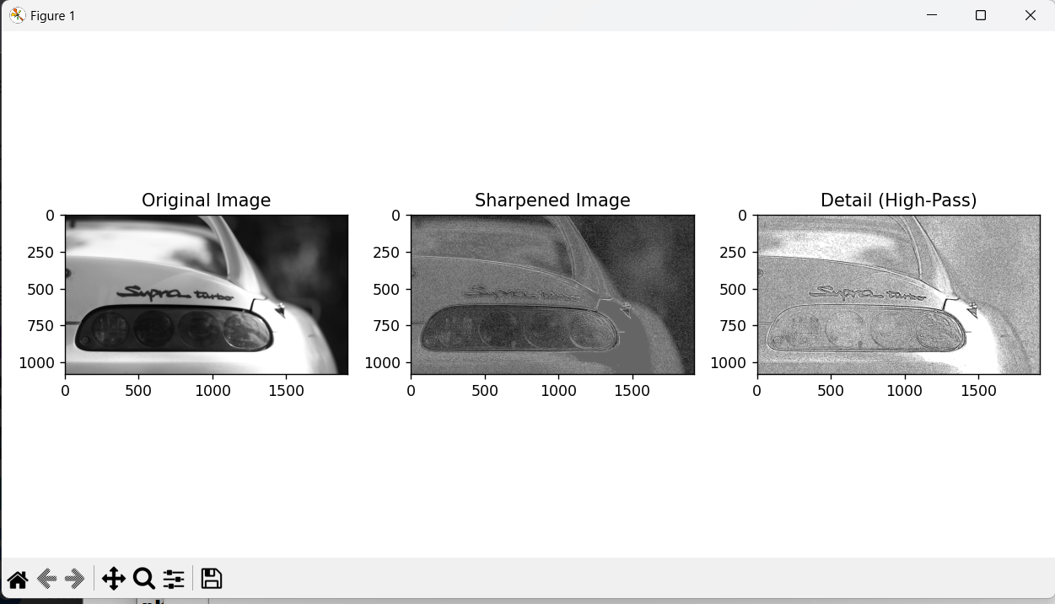

Q25.

AIM :

Perform Sharpening of Image using Gradient masking

SOURCE CODE :

import cv2

import numpy as np

import matplotlib.pyplot as plt

def sharpen_image_with_gradient(image_path, alpha=1.5):

original_image = cv2.imread(image_path, cv2.IMREAD_GRAYSCALE)

gradient_x = cv2.Sobel(original_image, cv2.CV_64F, 1, 0, ksize=3)

gradient_y = cv2.Sobel(original_image, cv2.CV_64F, 0, 1, ksize=3)

gradient_magnitude = np.sqrt(gradient_x**2 + gradient_y**2)

gradient_magnitude = cv2.normalize(gradient_magnitude, None, 0, 255, cv2.NORM_MINMAX, cv2.CV_8U)

sharpened_image = cv2.addWeighted(original_image, 1 + alpha, gradient_magnitude, -alpha, 0)

return original_image, sharpened_image

image_path = "C://Users//ASHIK C SABU//Desktop//supraaa//supra.jpg"

original_image, sharpened_image = sharpen_image_with_gradient(image_path, alpha=1.5)

plt.figure(figsize=(10, 5))

plt.subplot(1, 2, 1)

plt.imshow(original_image, cmap='gray')

plt.title('Original Image')

plt.subplot(1, 2, 2)

plt.imshow(sharpened_image, cmap='gray')

plt.title('Sharpened Image')

plt.tight_layout()

plt.show()

OUTPUT:

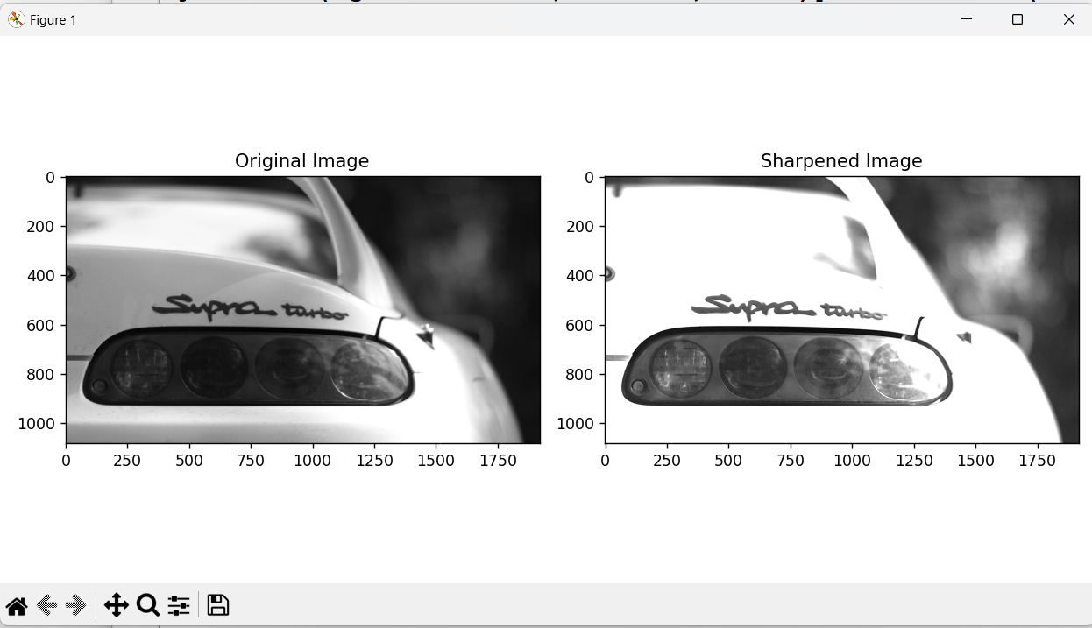

Q26.

AIM :

Insert water marking to the image using OpenCV.

SOURCE CODE :

import cv2

img = cv2.imread("C://Users//ASHIK C SABU//Desktop//supraaa//supra.jpg")

wm = cv2.imread("C://Users//ASHIK C SABU//Desktop//supraaa//supra1.jpg")

h_wm, w_wm = wm.shape[:2]

h_img, w_img = img.shape[:2]

center_x = int(w_img/2)

center_y = int(h_img/2)

top_y = center_y - int(h_wm/2)

left_x = center_x - int(w_wm/2)

bottom_y = top_y + h_wm

right_x = left_x + w_wm

roi = img[top_y:bottom_y, left_x:right_x]

result = cv2.addWeighted(roi, 1, wm, 0.3, 0)

img[top_y:bottom_y, left_x:right_x] = result

cv2.imshow("Watermarked Image", img)

cv2.waitKey(0)

cv2.destroyAllWindows()

OUTPUT:



Q27.

AIM :

Do Cropping, Copying and pasting image inside another image using OpenCV

SOURCE CODE :

import cv2

import numpy as np

image = cv2.imread("C://Users//ASHIK C SABU//Desktop//supraaa//supra.jpg")

img2 = cv2.imread("C://Users//ASHIK C SABU//Desktop//supraaa//supra1.jpg")

print(image.shape) # Print image shape

cv2.imshow("original", image)

imageCopy = image.copy()

cv2.circle(imageCopy, (100, 100), 30, (255, 0, 0), -1)

cv2.imshow('image', image)

cv2.imshow('image copy', imageCopy)

cropped_image = image[80:280, 150:330]

cv2.imshow("cropped", cropped_image)

cv2.imwrite("Cropped Image.jpg", cropped_image)

dst = cv2.addWeighted(image, 0.5, img2, 0.7, 0)

img_arr = np.hstack((image, img2))

cv2.imshow('Input Images',img_arr)

cv2.imshow('Blended Image',dst)

cv2.waitKey(0)

cv2.destroyAllWindows()

OUTPUT:

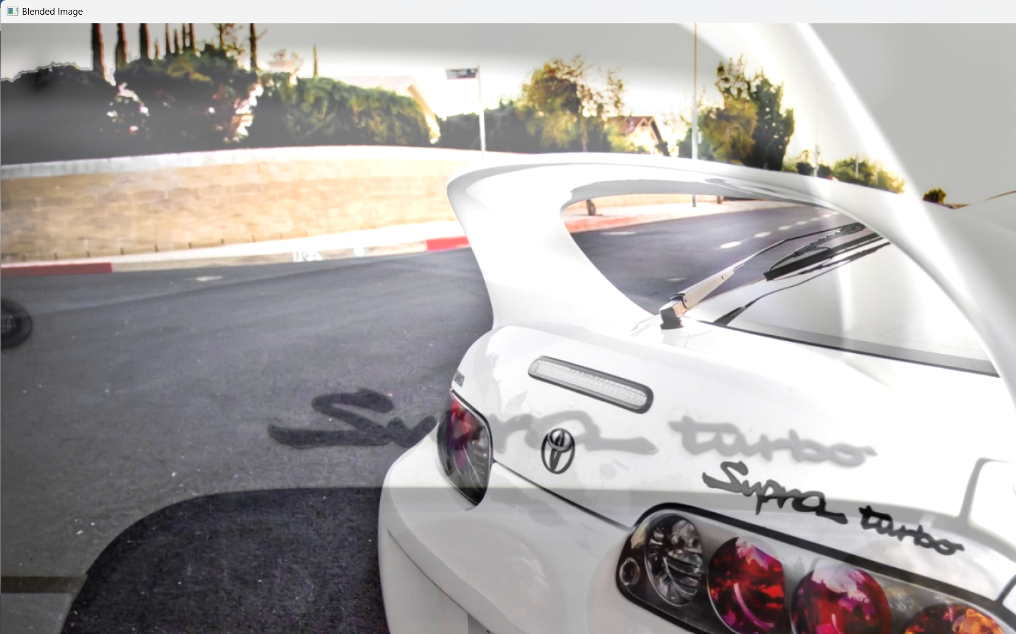

Q28.

AIM :

Find the boundary of the image using Convolution kernel for the given image

SOURCE CODE :

import cv2

import numpy as np

img = cv2.imread("C://Users//ASHIK C SABU//Desktop//supraaa//supra.jpg",cv2.IMREAD_GRAYSCALE)

dx = cv2.Sobel(img, cv2.CV_64F, 1, 0)

dy = cv2.Sobel(img, cv2.CV_64F, 0, 1)

edges = cv2.magnitude(dx, dy)

thresh = 100

edges[edges < thresh] = 0

edges[edges >= thresh] = 255

cv2.imshow("Edges", edges)

cv2.waitKey(0)

cv2.destroyAllWindows()

OUTPUT:

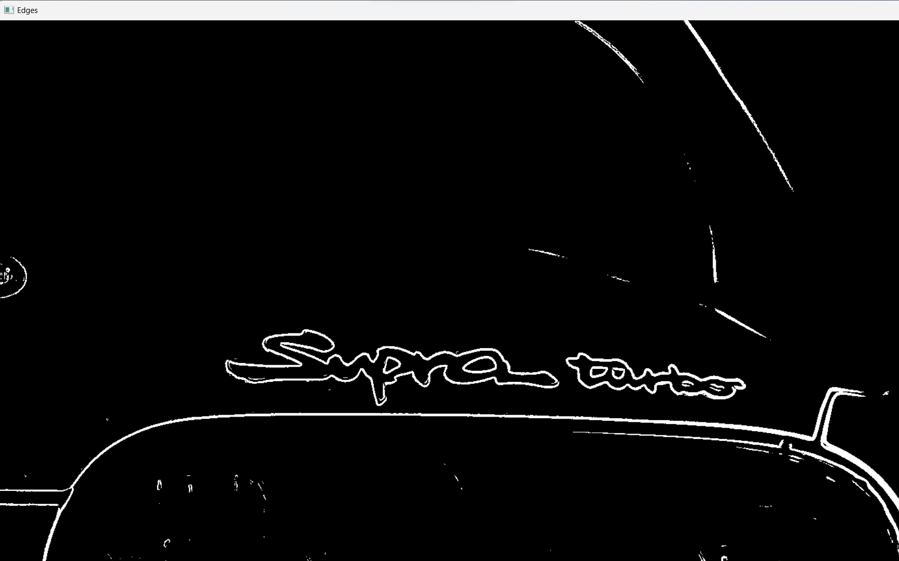

Q29.

AIM :

Morphological operations based on OpenCV using Erosion technique

SOURCE CODE :

import cv2

import numpy as np

img = cv2.imread("C://Users//ASHIK C SABU//Desktop//supraaa//supra.jpg",cv2.IMREAD_GRAYSCALE)

kernel = np.ones((5,5), np.uint8)

erosion = cv2.erode(img, kernel, iterations=1)

cv2.imshow("Original", img)

cv2.imshow("Erosion", erosion)

cv2.waitKey(0)

cv2.destroyAllWindows()

OUTPUT:

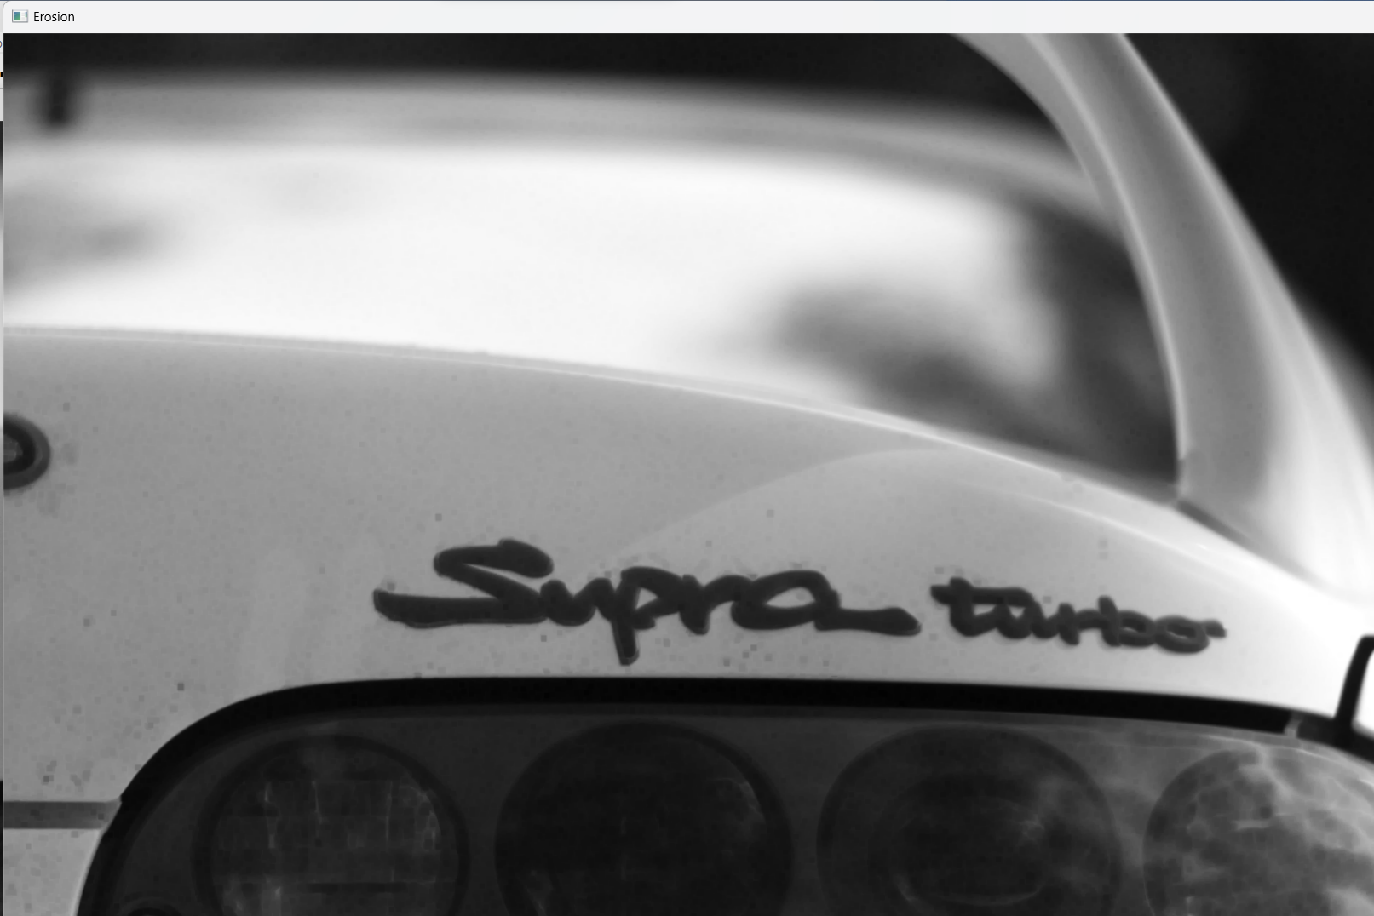

Q30.

AIM :

Morphological operations based on OpenCV using Dilation technique

SOURCE CODE :

import cv2

import numpy as np

img = cv2.imread("C://Users//ASHIK C SABU//Desktop//supraaa//supra.jpg", cv2.IMREAD_GRAYSCALE)

kernel = np.ones((5,5), np.uint8)

dilation = cv2.dilate(img, kernel, iterations=1)

cv2.imshow("Original", img)

cv2.imshow("Dilation", dilation)

cv2.waitKey(0)

cv2.destroyAllWindows()

OUTPUT:

